SECTION 10 71 19.16
REMOVABLE FLOOD BARRIERS

Part 1. GENERAL

1.1 SECTION INCLUDES

Flood Panels

1.2 RELATED SECTIONS

Section 03300 - Cast-In-Place Concrete

Section 04810 - Unit Masonry Assemblies

Section 05120 - Structural Steel

1.3 REFERENCES

ASTM B 209 - Standard Specification for Aluminum and Aluminum-Alloy Sheet and Plate.

ASTM B 211 - Standard Specification for Aluminum and Aluminum-Alloy Bar, Rod, and Wire.

Aluminum Association - Specification for Aluminum Structures, 7th Edition.

ASME Structural Welding Code Section IX.

FEMA Technical Bulletin 3-21 - Non-Residential Flood Proofing.

SEI/ASCE 7-16 - Minimum Design Loads for Buildings and Other Structures.

ASCE 24-14 AWS D1.2 - Structural Welding Code - Aluminum.

Aluminum Structures - A Guide to Their Specifications and Design.

U.S. Army Corps of Engineers, EP 1165-2-314 - Flood Proofing Regulations, 15 December 1995.

1.4 DESIGN / PERFORMANCE REQUIREMENTS

Design watertight panels to perform under load criteria as set forth is standards noted above. All water pressure loads and operating loads are transferred to the building structure.

Standard loading: Standard Flood Panels are designed for hydrostatic loading, hydrodynamic loads, wave loads and debris impact loads.

1.5 SUBMITTALS

Submit under provisions of Section 01300.

Manufacturer's data sheets on each product to be used, including:

Preparation instructions and recommendations,

Storage and handling requirements and recommendations,

Installation instructions.

Shop Drawings: Provide shop drawings showing layout, profiles, and product components, including anchorage, hardware, and finishes. Include dimensional plans, applicable material specifications, elevations and sections detailing mounting and connections, and load diagrams.

Closeout Submittals: Provide Operation and Maintenance data to include methods for maintaining installed products, precautions against cleaning materials, and methods detrimental to finishes and performance.

1.6 QUALITY ASSURANCE

Manufacturer Qualifications: Manufacturer must demonstrate previous successful experience in design and manufacture of similar flood-related closures. Upon request, provide supporting evidence including list of installations, descriptions, name, and method of contact.

Welder Qualifications: Welders certified in accordance with American Welding Society Procedures: AWS-1-GMAW-S, WPS No. B2.004.90 for applicable material used in production of specified product.

DELIVERY, STORAGE, AND HANDLING

Store products in manufacturer's unopened packaging container with identification labels intact until ready for installation.

Protect materials from exposure to moisture.

Store materials in a dry, warm, ventilated, weather-tight location. If outdoor storage is required, block materials to store at an incline, to prevent pooling of any moisture and pro-mote runoff. Tarp materials in a tent-like arrangement, elevated above the product with open sides to allow airflow. Store all other hardware in a dry controlled environment.

Store materials so that no damage occurs to gaskets and attached hardware.

Use caution when unloading and handling product to avoid bending, denting, crushing, or other damage to the product.

When using forklifts, use forks of proper length to fully support product being moved. Consult shop drawings or consult with factory for proper lift points.

1.8 PROJECT CONDITIONS

Maintain environmental conditions (temperature, humidity, and ventilation) within limits recommended by manufacturer for optimum results. Do not install products under environmental conditions outside manufacturer's absolute limits.

1.9 COORDINATION

Coordinate work with other trades, operations, and installation of adjacent materials to avoid damage.

1.10 WARRANTY

Watertight closure shall operate satisfactorily and be free of defects in material and workmanship for a period of not less than one year from the date of delivery

Part 2. PRODUCTS

2.1 DISTRIBUTORS & MANUFACTURERS

Acceptable Distributor:

Floodproofing.com
19 Mantua Road
Mount Royal, NJ 08061

Acceptable Manufacturer:
Flood Risk America
720 Lucerne Avenue, Suite 567
Lake Worth, FL-33460

Contact:

Floodproofing.com, 800-507-0865, PLANS@Floodproofing.com

Substitutions:

Not Permitted

Obtain all watertight doors and window panel assemblies from single manufacturer

2.2 EQUIPMENT

Watertight Door and window panels: Provide the following panels:

FRA Door Panel: Flood Risk America

FRA Window Panel: Flood Risk America

Product Details:

Sealing Requirements: Flood Panel and gasket design shall provide an effective seal for short-term high water situations, to the protection level indicated on drawings.

Operation: Panels are non-operable.

Mounting/Load Transfer: Anchor to existing structure. Flood Panel designed for specified hydrostatic pressure (and other loads as specified) and will transfer loads to adjacent structure.

Panels to be anchored utilizing mechanical, anchor types as designed. Manufacturer to include all anchors, water-stop, and sealants, as designed.

Loading Direction Selection:

Standard: Positive Pressure Loading: (Direction of loading against flood panel so as to further compress gaskets against flood panel frame-"seating").

Optional: Reverse Pressure Loading: (Direction of loading against flood panel so as to force the flood panel away from the structure-"unseating").

Provide compression gasket, which requires no inflation.

Provide anchoring to all structural elements.

2.3 MATERIALS

A. Flood Panel:

Composite FRP / IPN chemical structure panels

B. Gaskets to be factory mounted to flood panel assembly. Gaskets to be
compressible closed cell type, and to be field replaceable.

Jamb members to be designed and fabricated with appropriate material as required for the loading.

Aluminum 6061 of appropriate size and strength with welded or
mechanical fastened construction.

Polyfiber of appropriate size and strength with epoxied or mechanical
fastened construction.

Sill members to be designed and fabricated with appropriate material as required for the loading:

Aluminum 6160 of appropriate size and strength with welded or mechanical fastened construction.

Polyfiber of appropriate size and strength with epoxied or mechanical fastened construction.

Panel Mounting Hardware: Provide hardware sized for the size and weight of
the flood panel and loads. Hardware to be factory located on panels, as
practical. All loads are transferred to building structure.

Anchors: Manufacturer provided stainless steel 304 anchors as noted on shop drawings.

Aluminum products to be mill finish, welds are ground smooth, not polished, and are factory acid washed, neutralized and rinsed.

Labeling. Each watertight panel and frame will be individually identified for matched installation.

2.4 FABRICATION

Fit and shop assemble items in largest practical sections, for delivery to site.

Fabricate items with joints tightly fitted and secured.

Supply components required for anchorage of fabrications. Fabricate anchors and related components of same material and finish as fabrication, except where specifically noted otherwise.

Part 3. EXECUTION

3.1 EXAMINATION

Do not begin installation until substrates have been properly prepared.

If substrate preparation is the responsibility of another installer, notify Architect of unsatisfactory preparation before proceeding.

3.2 PREPARATION

Clean surfaces thoroughly prior to installation.

Prepare surfaces using the methods recommended by the manufacturer for achieving the best result for the substrate under the project conditions.

3.3 INSTALLATION

Install in accordance with manufacturer's installations instructions, approved shop drawings, shipping, handling, and storage instructions, and product carton instructions for installation.

Panels shall be installed level, square, plumb, and rigid.

Sealants, water-stop, and grouting to be applied per product application directions and in accordance with manufacturer's instructions.

Tolerances: All dimensional requirements must be in accordance with manufacturer's installation instructions and shop drawings.

3.4 FIELD QUALITY CONTROL

Products to be operated and field verified including the sealing surfaces to assure that they maintain contact at the correct sealing points.

Verify all anchorage is in accordance with manufacture's installation instructions and applicable data sheets.

3.5 CLEANING

Repair or replace damaged installed products or components.

Clean all sealing surfaces.

Touch up damaged finish.

Part 4.

3.6 PROTECTION

Protect installed products until completion of project.

Touch-up, repair, or replace damaged products before substantial completion.

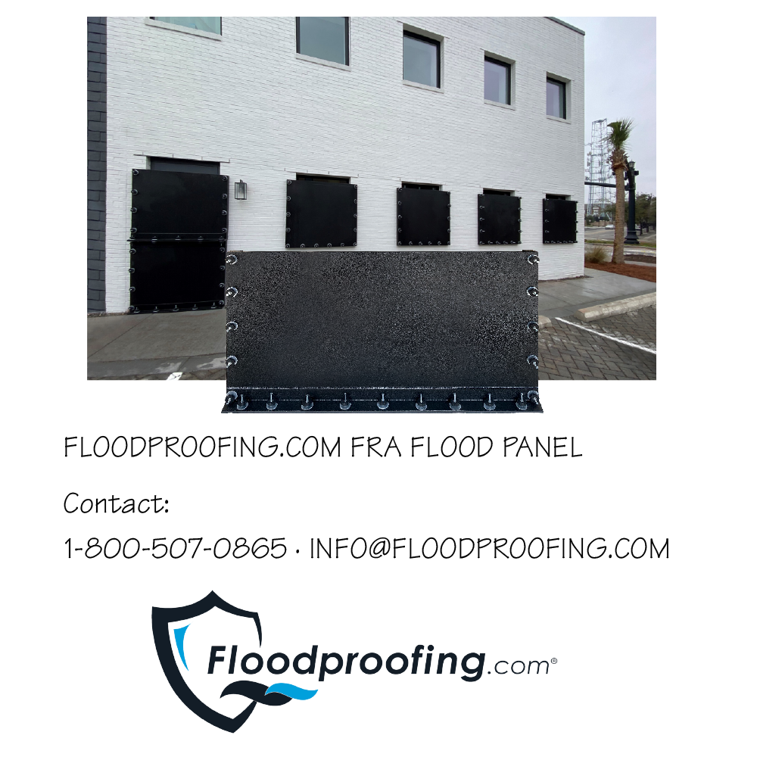
END OF SECTION

