SPECIFICATIONS SECTION 10 71 19

FLOOD CONTROL GATES

PART 1 GENERAL

  - SECTION INCLUDES
    - Flood Gates for vehicular and pedestrian use

  - RELATED SECTIONS

    - N/A.
  - REFERENCES

    - ASTM C 39 - Standard Test Method for Compressive Strength of Cylindrical Concrete Specimens.

    - ASTM F593 – Standard Specification for Stainless Steel Bolts, Hex Cap Screws and Studs.

    - AWS - American Welding Society.

    - FEMA - Federal Emergency Management Agency.

    - The Aluminum Association - Aluminum Design Manual, 2015
    - ASCE 7-2010 – Minimum Design Loads for Buildings and Other Structures, 2010

  - DEFINITIONS

    - Mitigation Height: The height of flood waters based on the local FEMA five-hundred
(500) year flood plain plus one (1) inch.

  - SUBMITTALS

    - Submit under provisions of Section xxx
    - Product Data: Manufacturer's data sheets on each product to be used, including:
      - Preparation instructions and recommendations.
      - Storage and handling requirements and recommendations.
      - Installation methods.
    - Shop Drawings: Submit plan, section, elevation and perspective drawings as necessary to depict proper placement, installation and operation methods for each gate to be installed.

  - QUALITY ASSURANCE

    - Manufacturer Qualifications: All primary products specified in this section will be supplied by a single manufacturer with a minimum of 5 years of experience in design and manufacturer of passive flood barrier systems and evidence of a minimum of 25 projects.

    - Installer Qualifications: All Work listed in this section is to be installed by a contractor approved by FloodBreak. FloodBreak representative must be on-site during gate installation to provide advisory services.

    - Mock-Up: Provide a mock-up for evaluation of surface preparation techniques and application workmanship.
      - Finish areas designated by Architect.
      - Do not proceed with remaining work until workmanship, color, and sheen are approved by Architect.
      - Refinish mock-up area as required to produce acceptable work.

  - DELIVERY, STORAGE, AND HANDLING
    - Store products in manufacturer's unopened packaging until ready for installation.

    - Store and dispose of hazardous materials, and materials contaminated by hazardous materials, in accordance with requirements of local authorities having jurisdiction.

  - PROJECT CONDITIONS

    - Maintain environmental conditions (temperature, humidity, and ventilation) within limits recommended by manufacturer for optimum results. Do not install products under environmental conditions outside manufacturer's absolute limits.

  - WARRANTY

    - At project closeout, provide to Owner or Owners Representative an executed copy of the manufacturer's standard limited warranty against manufacturing defect, outlining its terms, conditions, and exclusions from coverage.
PART 2 PRODUCTS
  - MANUFACTURERS and DISTRIBUTORS

    - Acceptable Manufacturer: FloodBreak Automatic Floodgates, which is located at: 2800 Post Oak Blvd. Suite 5850; Houston, TX 77056

    - Distributor: Floodproofing.com located at 19 Mantua Road Mount Royal, NJ 08061 Phone: 800-507-0865 Email: info@floodproofing.com

    - Substitutions: Substitutions are not allowed

  - APPLICATIONS/SCOPE

    - Provide a means of passively protecting human and property assets subject to damage during a flood caused by external forces. Passive shall mean that the gate functions without human intervention, power or mechanical assists to make the gate deploy and drain.

  - DESIGN REQUIREMENTS

    - Design gate height based on the Mitigation Height at the location of the gate as determined by the Federal Emergency Management Agency (FEMA) or equivalent entity.

    - Design the gate to allow safe passage of vehicular and human traffic while in its dry or "Closed" position.

    - Design the gate to hinder the passage of floodwater and resist flood forces (hydrostatic pressures plus hydrodynamic pressures for water running at 5 ft. per second.

    - Per client request additional flooding loads could be considered, such as debris loads or greater hydrodynamic pressures.
    - For the vehicular gates, while the gate is in the “Closed” position it should be able to sustain traffic loads corresponding to AASHTO HS-25 (40 ton) truck.

For the pedestrian gates, while the gate is in the “Closed” position it should be able to sustain a live load of 100 psf.

    - Design the gate to exclude the use of any electric or mechanical powered support equipment, springs, or pumps, for any operation of the gate to its open or closed position in passive mode.

    - Design the system to include the ability to actively power the gate into operating position using a powered lift system. The active power system shall be fully decoupled so that at no time will it interfere with or be required for the fully passive operation of the gate, regardless of power availability.

    - Design that the actual gate installation “set-down” below surface grade is a maximum of 12 inches for pedestrian openings and vehicular applications and 24 inches if including optional lift. Gate shall anchor into structural foundation.

Design the gate system using only aluminum and stainless-steel components to resist corrosion and EPDM rubber gaskets for durability.
  - COMPONENT

    - Concrete: ASTM C 39 concrete; Compressive strength as recommended by project engineer.

    - Pan Inlet Grate:
      - Vehicular Grates: 3/8 by 1 inch (10mm x 25mm) flat aluminum bar spaced 3/8 inch (10mm).
      - Pedestrian Grates: 1/8 by 1 inch (3mm x 25mm) flat aluminum bar spaced 1/8 inch (3mm)

    - Gaskets: 3/16-inch (4.8mm) EPDM rubber.
    - Lid Stiffener Tubing:
      - Material: 2 inch by 2 inch x ¼” (51mm x 51mm x 6mm) square tubes - Grade 6063–T6 aluminum.
      - Minimum Yield (Fy): 25 ksi.

    - Pan Support Tubing for vehicular gates:
      - Material: 1/4 inch (6mm) structural 2 inches by 2 inch (51mm x 51mm) square tubes - Grade –T6 aluminum.
      - Minimum Yield (Fy): 25 ksi.

    - Pan Stiffeners for pedestrian gates:
      - Material: 1/4 (38mm x 13mm) 6061-T651 Aluminum flat stock.
      - Minimum Yield (Fy): 35 ksi.
    - Pan:
      - Material: 1/4 inch (6mm) smooth plate - Grade 5052 Aluminum.
      - Minimum Yield (Fy): 25.8 ksi.

    - Gasket Flanges:
      - Material: 1/4 inch (6mm) 6061-T6 aluminum.
      - Minimum Yield (Fy): 35 ksi.
    - Retention Arm:
      - Material: 1-1/2 inch by 1/2 inch (38mm x 13mm) 6061-T651 Aluminum flat stock.
      - Minimum Yield (Fy): 35 ksi.

    - Structural Angles:
      - Material: 1/4-inch (6mm) structural 2 inch by 2 inch (51mm x 51mm) angles - 6061-T6 aluminum.
      - Minimum Yield (Fy): 35 ksi.

- Lid:
  - Material: 5” x 2 ½” x 1/8” (127mm x 63mm x 3mm) 1- 6005-T5 aluminum extrusion. Minimum Yield (Fy): 35 ksi for vehicular gates.
  - Material: 3/16” (5mm) smooth plate on dry side - 5052.
Minimum Yield (Fy): 25.8 ksi and ¼” (6mm) smooth plate on wet side
- 5052 Minimum Yield (Fy): 25.8 ksi for pedestrian gates.

- Pan and Lid Yoke Plates:
  - Material: ½ inch (12mm) plate - Grade 5052 Aluminum.
  - Minimum Yield (Fy): 25.8 ksi
- Structural Channels for Pedestrian Gates Lid:
  - Material: 6061-T6 aluminum.
  - Minimum Yield (Fy): 35 ksi.

- Cell foam filler for pedestrian gates, density =0.85 lbs per cubit feet.
- Hardware:

  - Concrete Anchor Bolts:
    - Material: 1/2-inch (13mm) diameter ASTM F593 Grade 304 Stainless Steel.

    - Minimum Yield (Fy): 50 ksi.

  - Hinge Pins:
    - Material: 1/2-inch (13mm) diameter ASTM F593 Grade 304 Stainless Steel.

    - Minimum Yield (Fy): 50 ksi.
  - Bolts:

    - Material: Countersunk ASTM F593 Grade 304 Stainless Steel bolts. Bolt diameter as noted on the contract drawings.

    - Minimum Yield (Fy): 50 ksi.

  - Retention Arm Anchors:

    - Material: ½-inch (13mm) ASTM F593 Grade 304 Stainless Steel.
    - Minimum Yield (Fy): 50 ksi.

- Welding Wire: Aluminum Wire - ER 4043 AWS A5.10

  - FABRICATION

    - General Requirements:
      - Fabricate all components and elements following the standards, tolerances and guidelines noted in the contract drawings.
- All welding to be performed by a certified welder in accordance with AWS standards and guidelines.
- Tighten all bolts to torque specifications determined by the manufacturer and Engineer of record.

    - Concrete: Encapsulate pan and extending bars in a monolithic concrete pour with a depth of no less than 11 inches (280mm) and extending a lateral distance from the pan no less than 12 inches (305mm) in any direction.

    - Pan:
Fabricate pan to include a drainage trough running parallel to and for the entire length of the gate at the approximate centerline of the pan. Trough will have a depth of 2 inches (51mm) and a width of 6 inches (152mm).
    - Drainage: Connect 4-inch (102mm) diameter drain to the drainage trough centered within the pan in all directions.

    - Gate:
      - At panel joints, stitch weld every 5 inches (127mm) on center with a 3/16-inch fillet weld 3 inches (76mm) long. Contractor shall verify with Engineer of Record these weld requirements prior to start fabrication.
      - At panel splices, place splice flanges within 12 inches (305mm) of adjacent retention arms. Contractor shall verify with Engineer of Record these weld requirements prior to start fabrication.

    - Hinges and Anchors:
      - Seam-weld retention arm brackets to gate and pan. Include stiffener plates on each side.
      - Attach retention arm anchors through pan and into concrete with 1/2 inch (13mm) diameter anchor bolts.
    - Wiper Wall: Manufacturer to provide 3/8 inch (10mm) aluminum wiper wall to maintain contact with gate seal and protective gaskets at all points of operation.

  - DRAWING
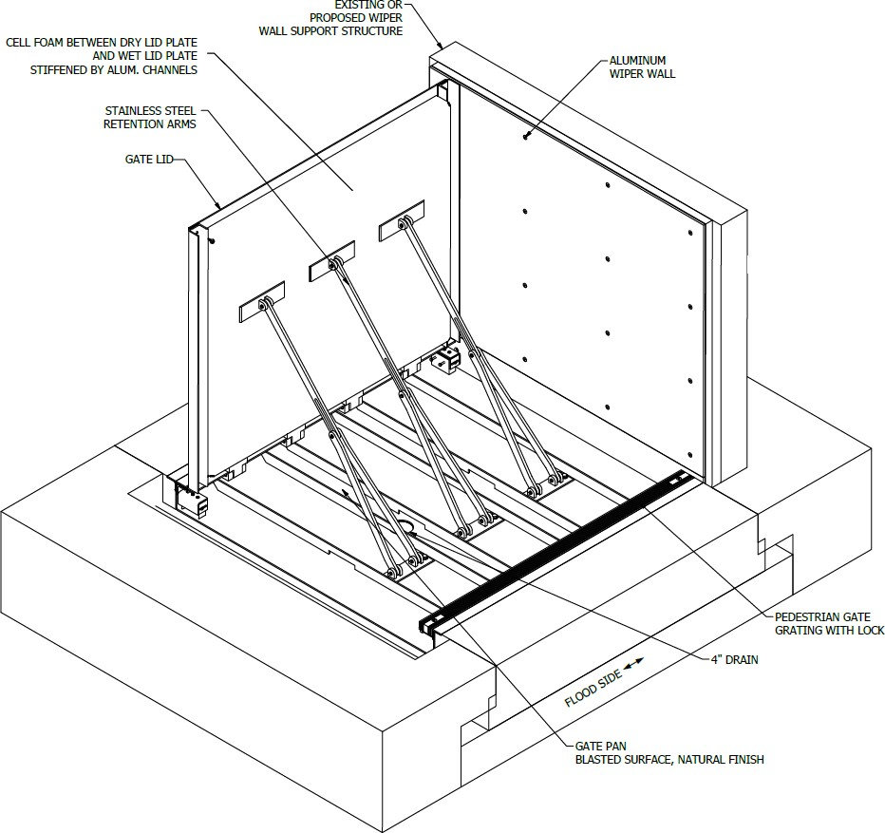
PEDESTRIAN GATE

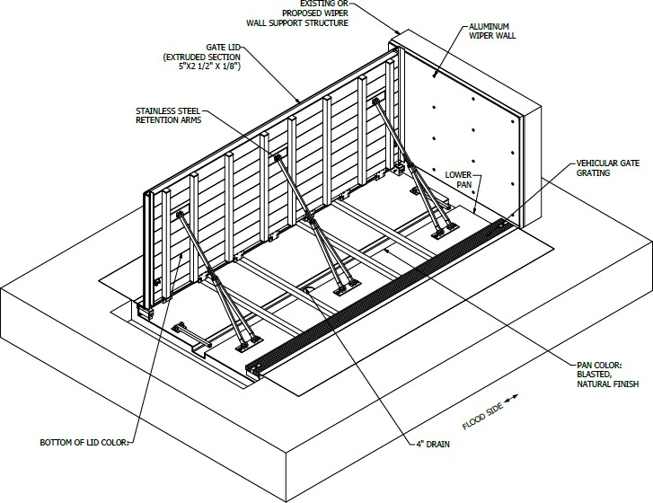

VEHICULAR GATE
PART 3 EXECUTION
  - EXAMINATION

    - Do not begin installation until substrates have been properly prepared.
    - If substrate preparation is the responsibility of another installer, notify Architect of unsatisfactory preparation before proceeding.

  - PREPARATION
    - Clean surfaces thoroughly prior to installation.

    - Prepare surfaces using the methods recommended by the manufacturer for achieving the best result for the substrate under the project conditions.
  - INSTALLATION

    - Install in accordance with manufacturer's instructions.

  - PROTECTION
    - Protect installed products until completion of project.

    - Touch-up, repair or replace damaged products before Substantial Completion.

END OF SECTION
